# How to manage HDFS and MapReduce job using HUE

1. Open Cloudera web browser

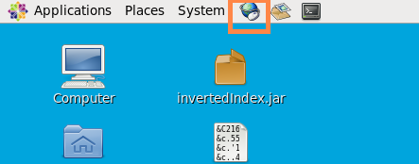

1. Click Hue tag to the Hue login window

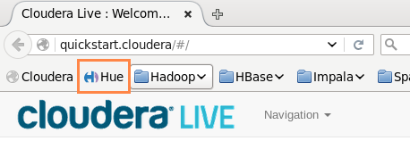

1. Login Hue

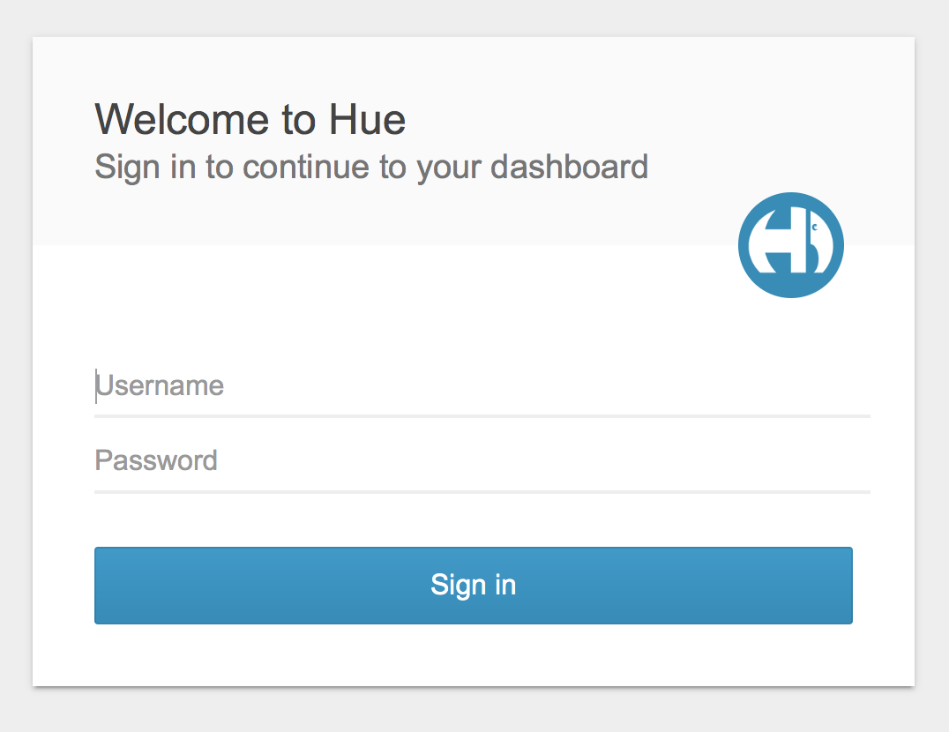

Username: cloudera

Password: cloudera

1. File Browser and job browser are located at top right corner



1. In file browser you can manage your HDFS files, including upload file, create folder, move and delete

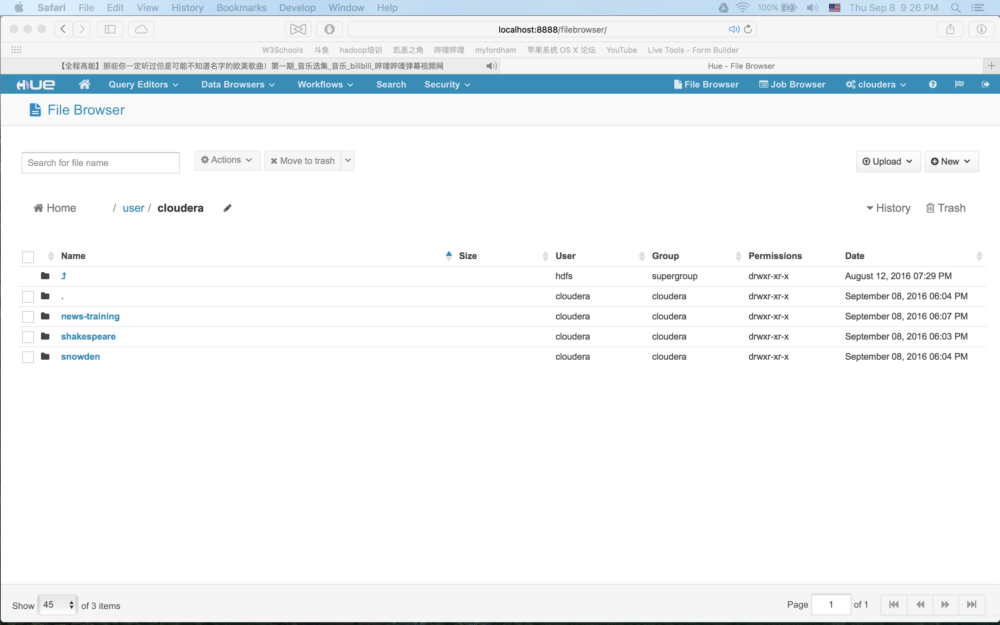

1. In job Browser, you can check MapR jobs process, manage or even, kill them.

